**WEEK - 2 : HANDS-ON EXERCISE**

**SLF4J logging framework**

**Exercise 1: Logging Error Messages and Warning Levels**

**Scenario**

* You need to write a Java application that logs error and warning messages using SLF4J with Logback in Eclipse without using Maven.

**Step 1: Download JAR Files**

* SLF4J API 1.7.30
* Logback Classic 1.2.3
* Logback Core 1.2.3

**Step 2: Create a New Java Project in Visual Studio Code**

1. Open Visual Studio Code
2. Go to File → New Folder, name it SLF4JLogging
3. Inside that folder, create two subfolders:

* src/ for Java files
* lib/ for JARs

**Step 3: Add JARs to Your Project**

1. Place all 3 JARs inside the lib/ folder.
2. No GUI configuration is needed—JARs will be linked via the terminal using -cp "lib/*".

**Step 4: Create the Logging Class - LoggingExample.java**

Place this file in the src/ folder.

**CODE:**

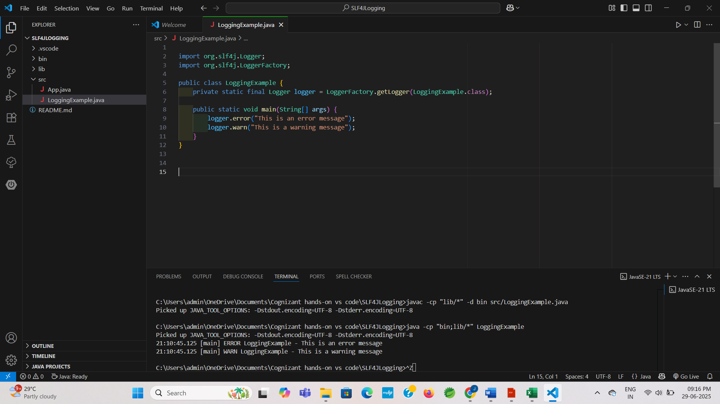

**OUTPUT:**

